Installation of maven using puppet code

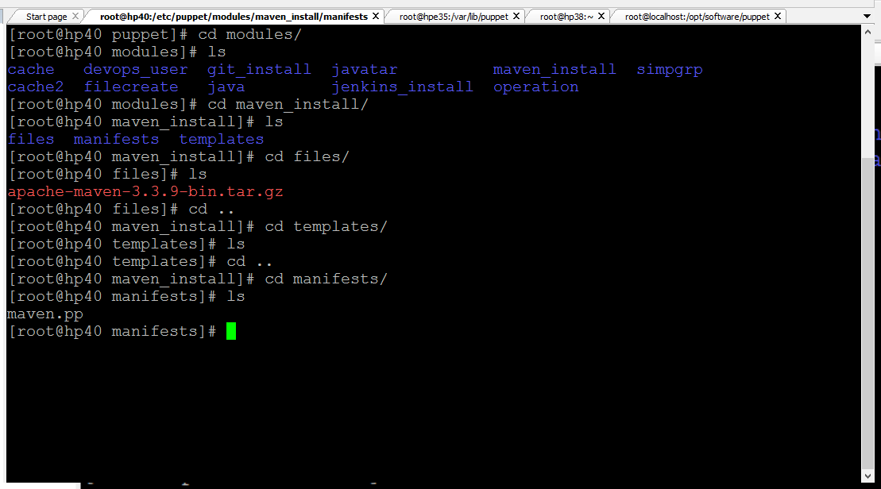

class maven_install::maven

{

#$maven_archive = "apache-maven-3.3.9-bin.tar.gz"

user { "maven":

ensure => 'present',

shell => '/bin/bash',

home => '/home/maven',

managehome => true,

}

file { "/opt/software/maven":

ensure => 'directory',

require => User['maven'],

owner => 'maven',

group => 'maven',

}

file { "/opt/software/maven/apache-maven-3.3.9-bin.tar.gz" :

ensure => 'present',

require => File['/opt/software/maven'],

source => 'puppet:///modules/maven_install/apache-maven-3.3.9-bin.tar.gz',

}

exec { "install" :

require => File['/opt/software/maven/apache-maven-3.3.9-bin.tar.gz'],

path => ["/bin/", "/usr/bin/", "/sbin/", "/usr/sbin/"],

cwd => '/opt/software/maven/',

command => 'tar -xvzf apache-maven-3.3.9-bin.tar.gz',

}

file { ".bashrc" :

path => '/home/maven/.bashrc',

content => template('maven_install/.bashrc'),

}

}

